Project Sri Lanka Permanent Fund

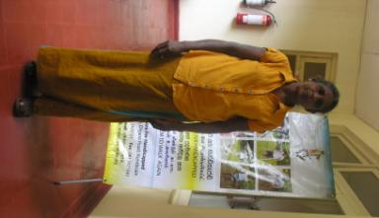

CENTRE FOR HANDICAPPED

Mrs. Rathnawathi, 61 years, lives with her children in Kadigamuwa a village located in Kurunegala District. She was a teacher before she lost her leg.

This is her tragic story:
When going to Ragama town one Sunday morning with my husband on his bicycle, I was hit by a container vehicle travelling very fast. I was badly injured, and immediately admitted to the Ragama General Hospital. The doctors there informed me that my left leg below the knee was very badly damaged and it should be amputated. I underwent surgery and stayed at the Hospital for nearly two months.
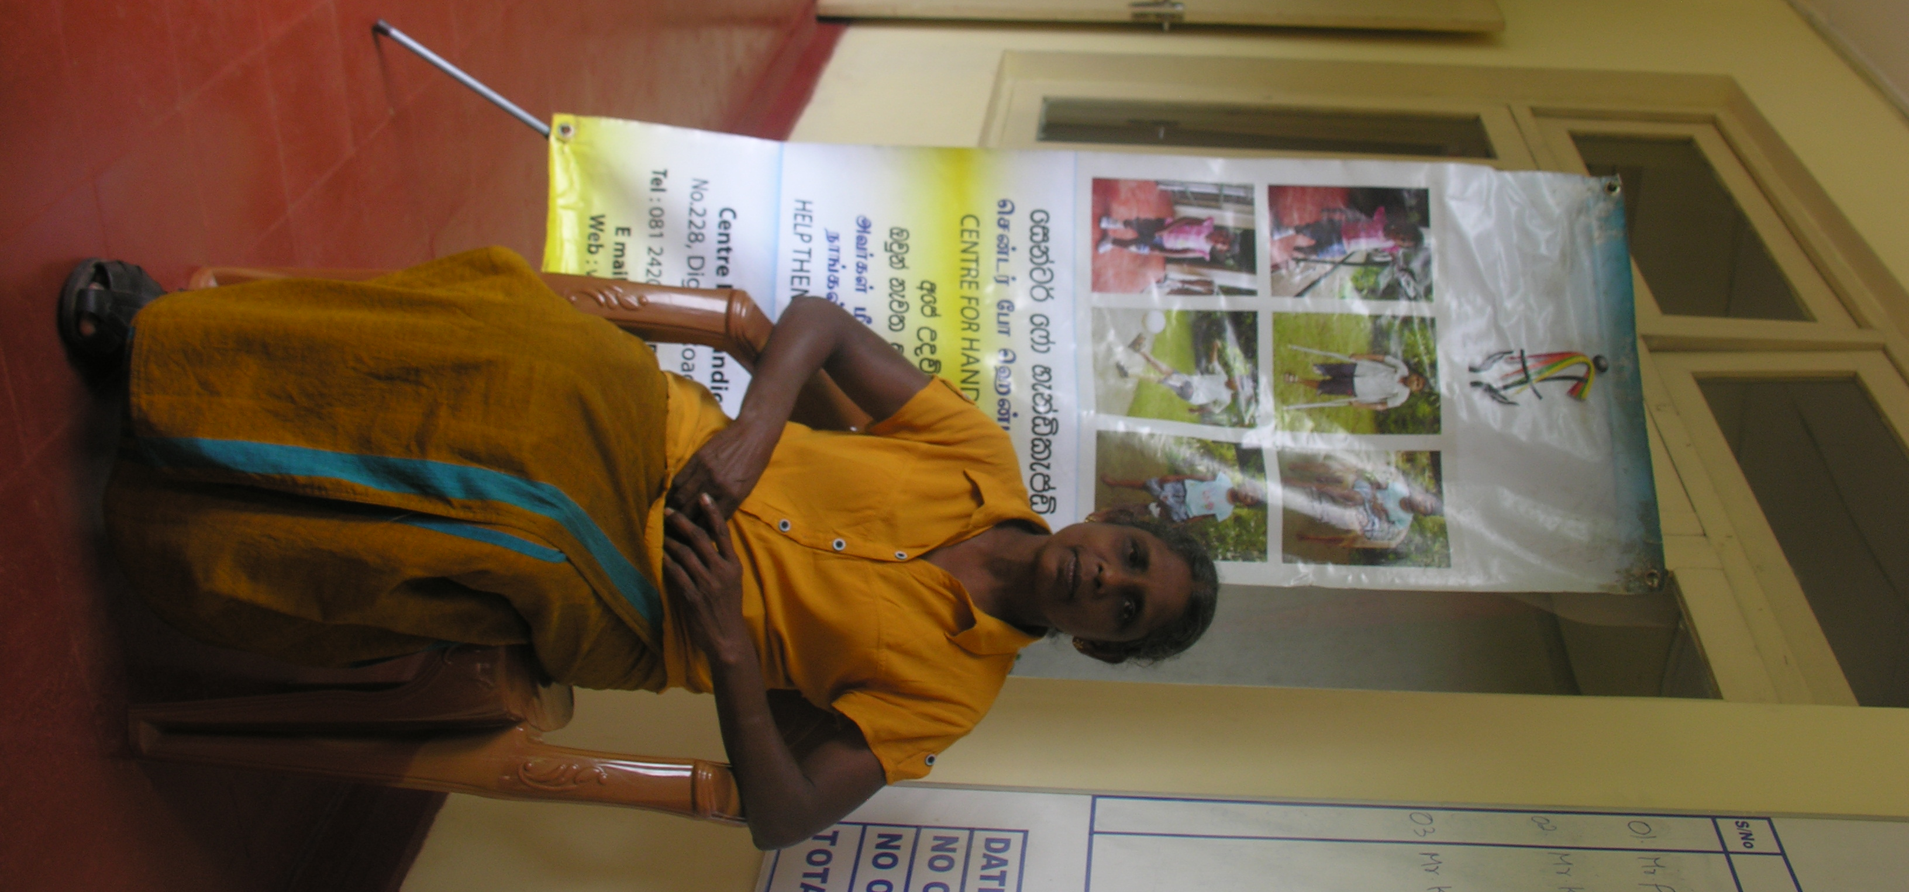
I was feeling sad and frustrated after the amputation of my leg. A friend told me about the Centre for Handicapped and that I could get an artificial leg from there. I visited the Centre and explained to the officials my difficulty in obtaining an artificial limb since I was going through a lot of financial difficulties. They understood my situation and decided to give me an artificial leg since there was sponsor. They took the required measurements and gave me a date to come back. When I returned, , I was fitted with an artificial leg which was made specially for me and was trained to walk. I felt very happy to be able to walk again.
I take this opportunity to thank the generous donor and also the staff at the Centre for Handicapped for their enormous support.

