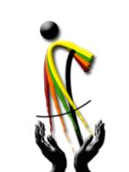

Thank you for your generosity

Mr. Y.G.C. Prasanna is 27 years old. He lives in Hanwella, a village in the Kandy District of Sri Lanka. He lives with his parents and two sisters. His father is a famer and a very poor income.
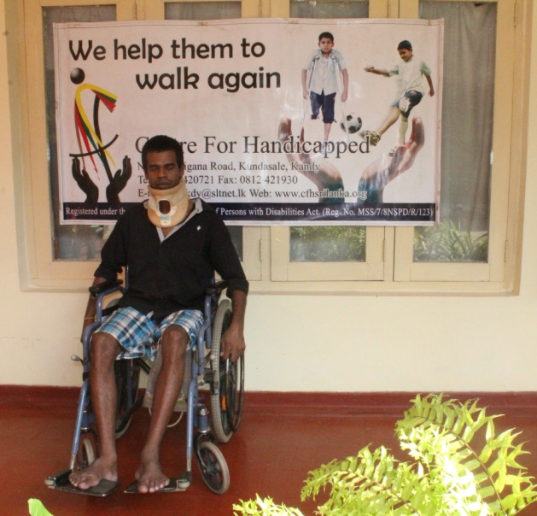
This is the story which he related to us:
This accident happened two months ago. I was working as a helper in an Auto service station. On the day of the accident, I was at my friend’s place close to my home. My friend and I climbed a tree and suddenly lost balance and I fell down and was unconscious. Immediately I was taken to the General Hospital Kandy by my relatives.
Once I gained consciousness I came to know that I was suffering from severe spinal cord injury and that I will not be able to walk without someone’s help. I was under medical treatment at the Kandy General Hospital for about a month and then transferred to the Digana Rehabilitation Hospital for further treatment.
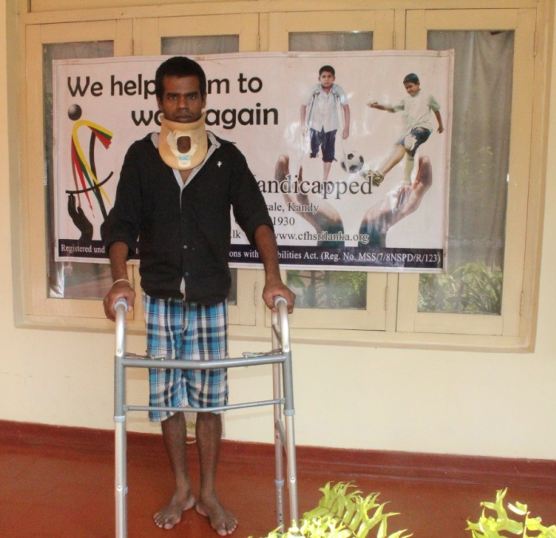
I came to know about the Centre for Handicapped through the Digana Rehabilitation Hospital and visited the Centre. After explaining my financial situation and about my family, the officers at the Centre said that there is device which is given free of charge by a Donor and that I will be able to walk with the aid of this device.
I am very grateful to the generous donor who gave this valuable device and the staff at CFH for helping me.

Few Photographs of Mr.Y.G.C. Prasanna
